|  |
| --- |
| Circle Language Spec: Commands |

## Command References in an Inactive Clause in a Diagram

This article demonstrates a situation of command objects.

This article illustrates how command references in an inactive clause look in a diagram.

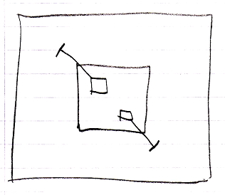

The large square is a command definition, the inactive clause is in. The square inside the large square is the inclause. The inactive clause contains two squares, which are the command references. They are actually *public* command references. This makes the command references parameters of the inactive clause. The command references have object lines, solid ones, going outside, ending at an access mark. Those object lines are indications of parameter passing, indicating that the command references are so called Reference parameters. Parameter passings are explained in the *Parameters* articles. The parameters are not filled in, because an inactive clause is a dormant command definition. Only in a call to the dormant command definitions, the parameters are filled in.